MICHAEL (TWIN) HARRIS UPCOMING EVENTS

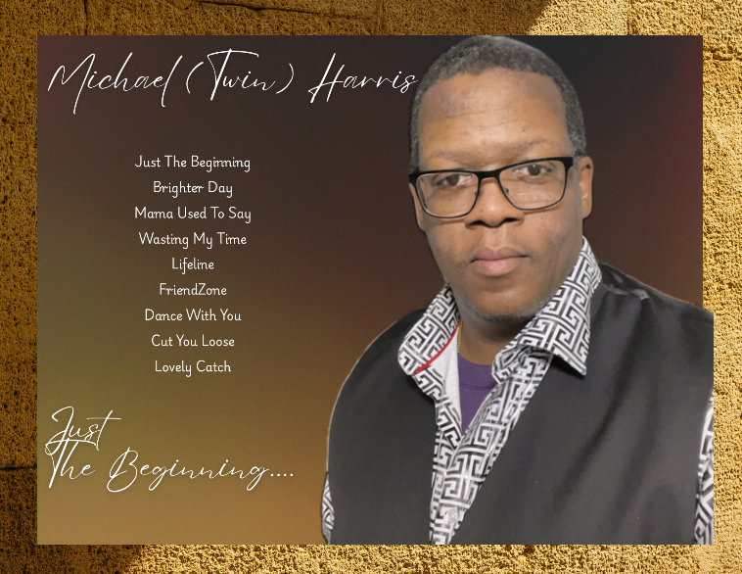

**MARCH 9, 2025 – A TOUCH OF CLASS EVENT HALL** (5:00PM – 9:00PM)

5103 THRUSH LANE, HENRICO, VA 23227 – ADVANCE TICKETS $30, DOOR PRICE $35

TICKETS CAN ALSO BE PURCHASED ON EVENTBRITE.

MORE DATES TO COME!!!!

STAY TUNED!!

